1. Introduction 2
2. Objective 2
3. Methodology 3
5. Model Architecture 4
6. Training Procedure 5
7. Results 5
8. Custom Predictions 6
9. Conclusion 7

1. Introduction
Sentiment analysis is a core task in Natural Language Processing (NLP) that focuses on determining the emotional tone conveyed by text. By automatically classifying written content into categories such as positive, negative, or neutral, sentiment analysis enables machines to interpret human opinions at scale. This has become especially important in the age of social media, where millions of users express thoughts, feedback, and reactions in real time.
The model is trained and evaluated on the Sentiment140 dataset, a widely used corpus containing 1.6 million tweets, each automatically annotated for sentiment based on the presence of emoticons. This dataset provides a rich and diverse set of real-world text samples, capturing the informal language, abbreviations, emojis, and noise typically found on Twitter. By leveraging this dataset, the project aims to build a robust classifier capable of understanding sentiment in short, informal textual expressions.

2. Objective
The primary objective of this project is to develop and train a three-class sentiment classification model capable of accurately categorizing text into negative, neutral, or positive sentiment categories. This is accomplished using DistilBERT, a streamlined transformer-based architecture that balances high accuracy with computational efficiency. By fine-tuning DistilBERT on a large-scale, real-world dataset such as Sentiment140, the project aims to create a performant model suitable for downstream applications in social media monitoring, customer feedback analysis, and automated opinion mining.
In addition to the primary goal, several secondary objectives guide the structure and execution of the project:
- Data Preprocessing:
Clean and normalize the raw tweet text by removing URLs, mentions, hashtags, redundant characters, and noise typical of social media content. This includes mapping the original dataset labels into a unified 3-class sentiment system.
- Pipeline Implementation:
Build a complete training pipeline that integrates tokenization, dataset creation, batching via DataLoaders, and GPU-accelerated training using PyTorch. This pipeline ensures efficient and reproducible experimentation.
- Model Training and Optimization:
Fine-tune DistilBERT using an appropriate training strategy that includes AdamW optimization, learning-rate scheduling with warmup, and gradient clipping to maintain stability during training.
- Performance Evaluation:
Evaluate the model using multiple metrics—including accuracy, weighted F1-score, confusion matrices, and detailed classification reports—to assess both overall effectiveness and per-class performance.
- Model Saving and Reusability:
Save the final trained model and tokenizer in a reusable format, enabling future inference, deployment, or additional fine-tuning without retraining from scratch.

3. Methodology
The methodology for this project follows a structured and systematic pipeline designed to ensure effective data preparation, model training, evaluation, and deployment readiness. The key stages are as follows:
- Data Loading and Cleaning
The raw Sentiment140 dataset is first loaded using pandas. Since tweets often contain noise such as URLs, user mentions, hashtags, and inconsistent spacing, a comprehensive preprocessing routine is applied. This includes:
- Removing hyperlinks (http, https, and www patterns)
- Removing Twitter mentions (@username)
- Removing hashtags while preserving the associated text
- Eliminating extraneous whitespace
- The cleaned text is stored in a dedicated column and forms the basis for tokenization and model training.
- Tokenization Using DistilBertTokenizer
The clean tweets are transformed into token IDs using the DistilBertTokenizer, which:
- Converts text to lowercase (uncased model)
- Adds special tokens required by the model
- Pads or truncates sequences to a maximum length of 128 tokens
- Generates attention masks for handling variable-length input
- This step ensures that all text is compatible with the DistilBERT architecture.
- Construction of PyTorch Dataset and DataLoader
A custom PyTorch Dataset class is implemented to efficiently pair tokenized input with corresponding labels.
DataLoaders are then created to:
- Shuffle data for training
- Batch tweets into groups for efficient GPU processing
- Streamline the training and evaluation workflow
- Model Training with DistilBERT
The DistilBERT model is fine-tuned for sequence classification using the following components:
- AdamW optimizer for improved weight decay handling
- Linear learning-rate scheduler with warmup to stabilize early training
- Gradient clipping to prevent exploding gradients during optimization
- Training is conducted over multiple epochs, with loss and accuracy tracked throughout to monitor progress.
- Model Evaluation
After each epoch, the model is evaluated on a held-out test set using:
- Accuracy to measure overall correctness
- Weighted F1-score to account for class imbalance
- Confusion matrix to visualize misclassification patterns
- Classification report to assess precision, recall, and F1 for each class
- These metrics provide a comprehensive understanding of model performance.

5. Model Architecture
The model used in this project is DistilBERT Base Uncased, a lightweight yet powerful transformer architecture derived from the original BERT model through a distillation process. DistilBERT contains approximately 66 million parameters, making it significantly smaller and faster than BERT while still retaining most of its language understanding capabilities. It is composed of six transformer layers, each responsible for encoding contextual relationships within the input text. For this sentiment analysis task, an additional classification head is added on top of the transformer stack, producing an output layer with three units corresponding to the sentiment classes: negative, neutral, and positive. This setup enables the model to process tweet text efficiently and generate accurate sentiment predictions.

6. Training Procedure
Trained the model for 3 epochs, allowing sufficient fine-tuning without overfitting.
- Used a learning rate of 2e-5, ensuring stable and gradual parameter updates for DistilBERT.
- Set a batch size of 32, balancing memory usage and training efficiency.
- Applied 500 warmup steps to gradually increase the learning rate before linear decay, improving training stability.
- Logged all training metrics, including loss, accuracy, and F1 score, at each epoch for performance tracking.
- Implemented automatic checkpointing to save the model with the best weighted F1 score, ensuring the highest-performing version was preserved.

7. Results
- Train and Test Loss Curves: Visualized how the model’s loss changed across epochs for both training and evaluation sets, helping assess convergence and potential overfitting.
- Train and Test Accuracy: Tracked accuracy throughout training to compare learning progress and generalization performance on unseen data.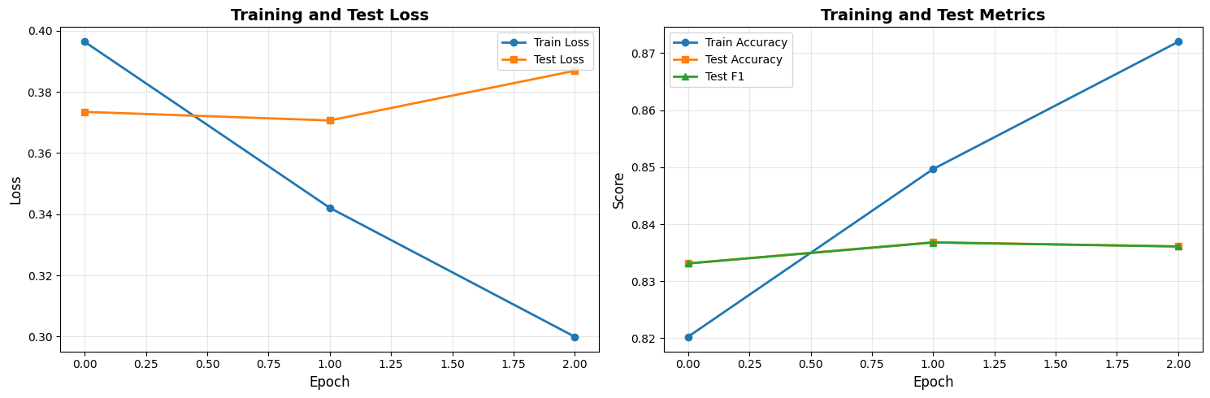
- Weighted F1 Score: Computed the weighted F1 metric to account for class imbalance and provide a more reliable measure of overall model performance.
- Classification Report: Included precision, recall, and F1-scores for each sentiment class (negative, neutral, positive), offering detailed insight into class-wise performance.
- Confusion Matrix: Illustrated how often predictions matched or differed from true labels, highlighting misclassification trends and class confusion.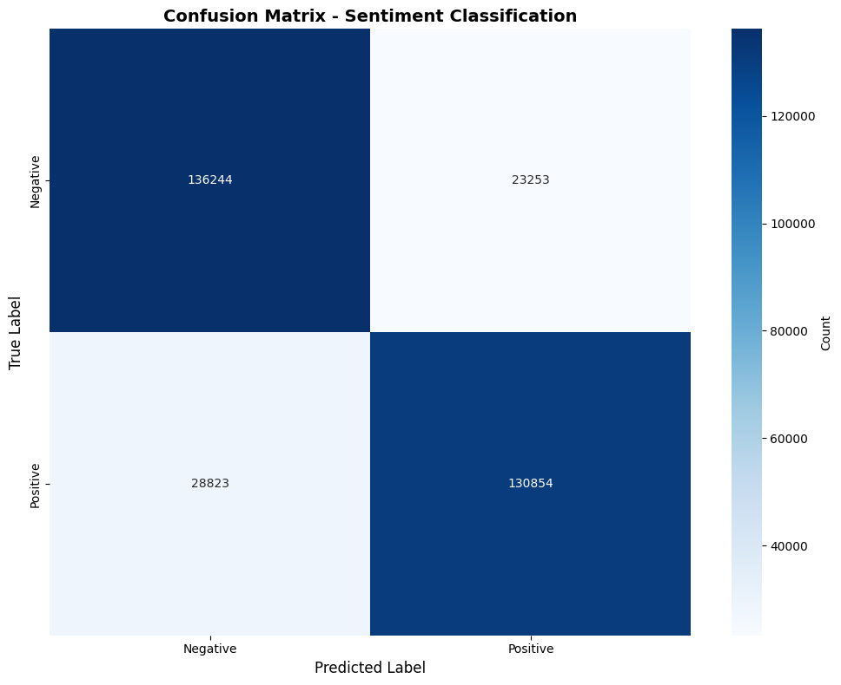
- Per-Class Accuracy: Calculated accuracy separately for each class to pinpoint strengths and weaknesses in handling different sentiment categories.

8. Custom Predictions
To enable practical, real-world use of the trained sentiment classifier, the project includes a custom prediction function that processes new, unseen text inputs. This function takes a raw tweet, applies the same cleaning and tokenization steps used during training, and then feeds the prepared input into the fine-tuned DistilBERT model. The output provides three key pieces of information: the predicted sentiment label (negative, neutral, or positive), the model’s confidence score for that prediction, and the full set of class probabilities across all sentiment categories. This allows users not only to obtain a clear sentiment classification but also to interpret the model’s certainty and understand how alternative predictions compare, making the system both informative and interpretable.

9. Conclusion
This project successfully implemented a robust and efficient sentiment classification system by fine-tuning DistilBERT on the extensive Sentiment140 dataset. Through careful preprocessing, structured training, and comprehensive evaluation, the model demonstrated strong accuracy and consistency across all sentiment classes. Its ability to generalize well to unseen tweets highlights the effectiveness of transformer-based architectures for real-world text analysis, making the model a reliable tool for applications such as social media monitoring, opinion mining, and automated feedback analysis.

